Q1. Write down the difference between DBMS and RDBMS.
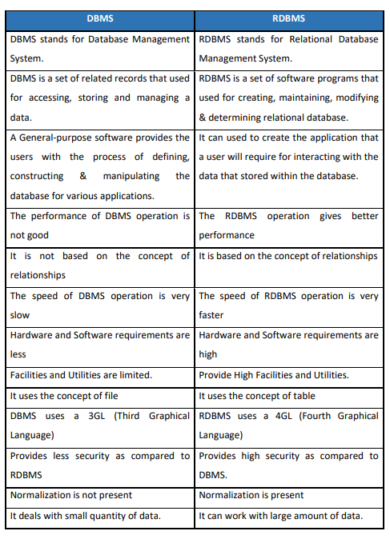

Q2. Write a note on database users
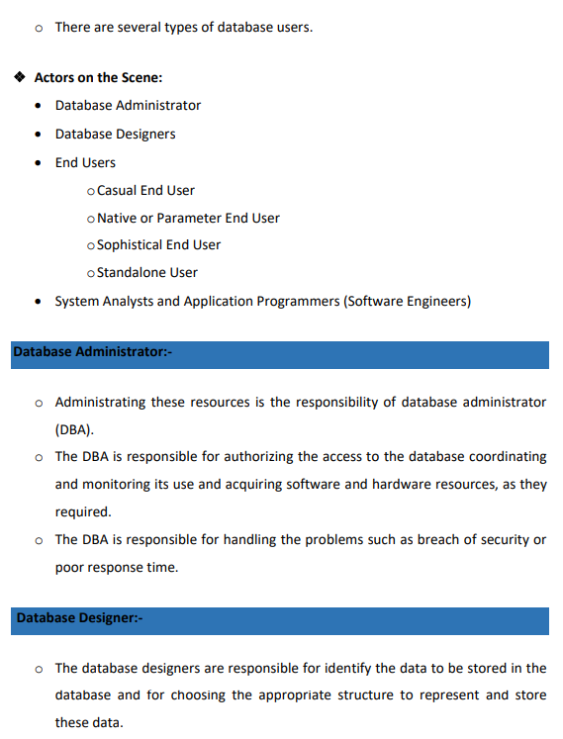

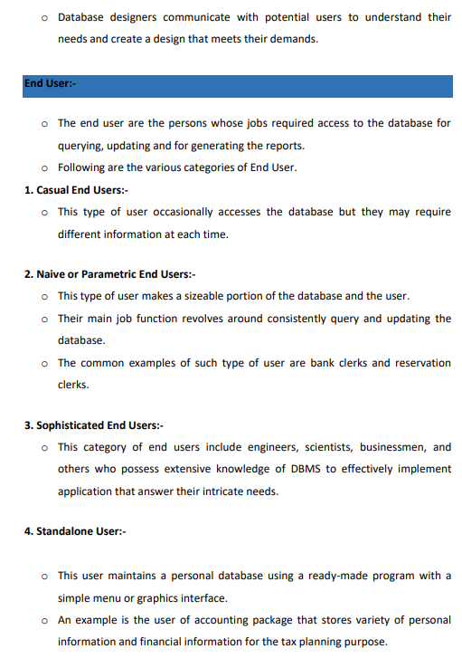



Q3. Explain functional dependency in detail
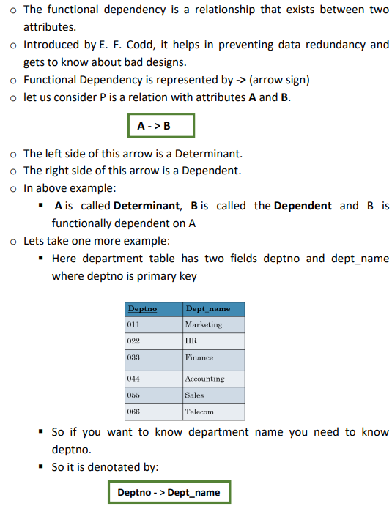

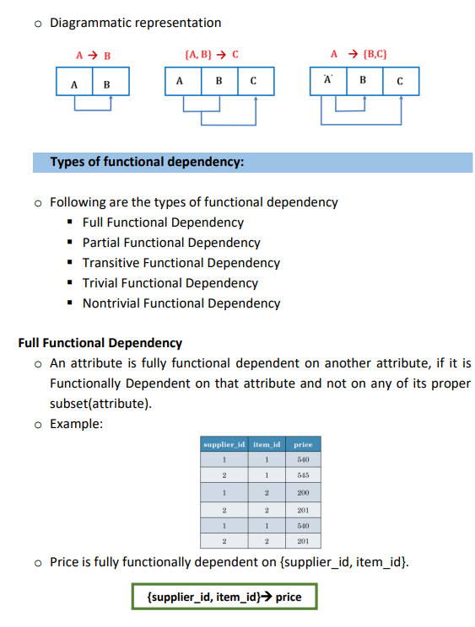

Q4. Explain normalization in details with example.
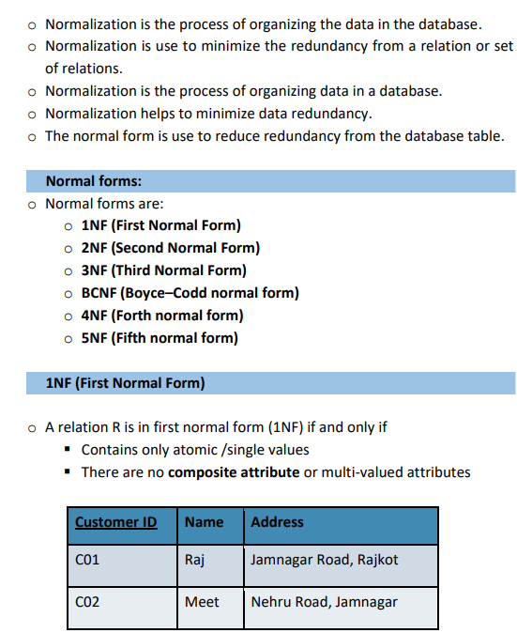

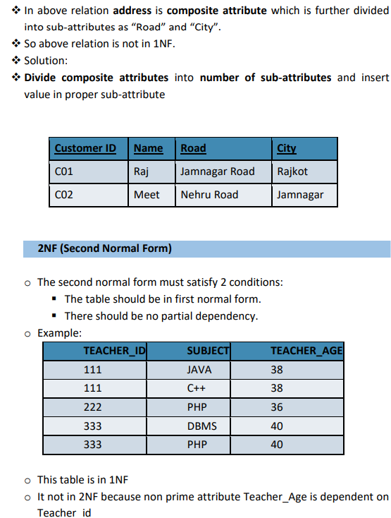

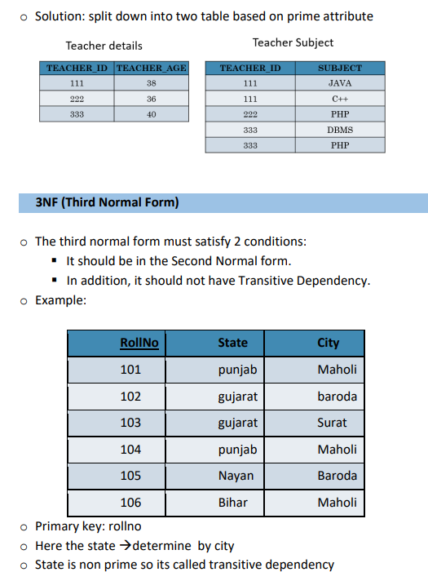

Q5. A booking table contains following fields. Write down query to construct the table using constraints and write down queries for all instructions also.

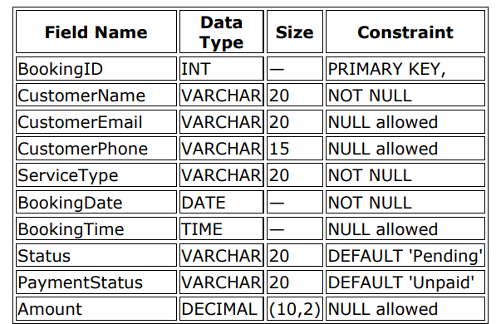

- Create table
CREATE TABLE Booking (
BookingID INT PRIMARY KEY,
CustomerName VARCHAR2(20) NOT NULL,
CustomerEmail VARCHAR2(20),
CustomerPhone VARCHAR2(15),
ServiceType VARCHAR2(20) NOT NULL,
BookingDate DATE NOT NULL,
BookingTime TIME,
Status VARCHAR2(20) DEFAULT 'Pending',
PaymentStatus VARCHAR2(20) DEFAULT 'Unpaid',
Amount DECIMAL(10,2)
);
- Describe table

DESC Booking;

OUTPUT
Name Null? Type
---------------- -------- ------------------
BOOKINGID NOT NULL NUMBER(38)
CUSTOMERNAME NOT NULL VARCHAR2(20)
CUSTOMEREMAIL VARCHAR2(20)
CUSTOMERPHONE VARCHAR2(15)
SERVICETYPE NOT NULL VARCHAR2(20)
BOOKINGDATE NOT NULL DATE
BOOKINGTIME TIME
STATUS VARCHAR2(20)
PAYMENTSTATUS VARCHAR2(20)
AMOUNT NUMBER(10,2)

- Insert statement to insert record
INSERT INTO Booking VALUES (1, 'Samir', 'samir@gmail.com', '9876543210', 'Cleaning', '2024-04-10', '10:00:00', 'Pending', 'Unpaid', 500.00);
INSERT INTO Booking VALUES (2, 'Suresh', NULL, '9876500000', 'Painting', '2024-04-12', '12:30:00', 'Completed', 'Paid', 1500.00);
INSERT INTO Booking VALUES (3, 'Ravi', 'ravi@yahoo.com', '9876511111', 'Plumbing', '2024-04-14', '09:30:00', 'Pending', 'Paid', 1200.00);
INSERT INTO Booking VALUES (4, 'Sneha', 'sneha@gmail.com', '9876522222', 'Electric', '2024-04-15', '15:00:00', 'Completed', 'Unpaid', 900.00);
INSERT INTO Booking VALUES (5, 'Amit', NULL, '9876533333', 'Repair', '2024-04-17', '11:00:00', 'Pending', 'Unpaid', 800.00);
OUTPUT
5 rows created.

- Display customer name, amount and payment status

SELECT CustomerName, Amount, PaymentStatus FROM Booking;

OUTPUT .
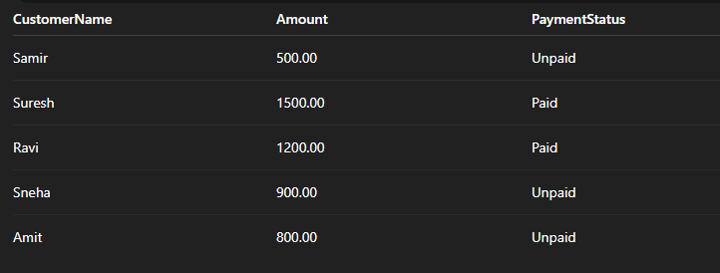

- Display all customers whose name begin with ‘S’
SELECT * FROM Booking WHERE CustomerName LIKE 'S%';
Output

- Display all whose email id is NULL
SELECT * FROM Booking WHERE CustomerEmail IS NULL;

Output

- Display all where status is ‘Pending’ and Payment status is ‘Paid’
SELECT * FROM Booking WHERE Status = 'Pending' AND PaymentStatus = 'Paid';
output

- Display all where status is ‘Pending’ OR Payment status is ‘Unpaid’
SELECT * FROM Booking WHERE Status = 'Pending' AND PaymentStatus = 'Paid';
Output
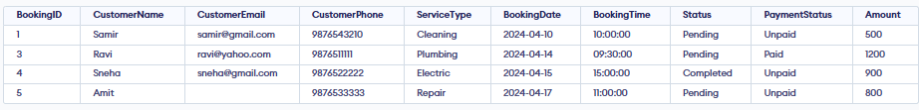
- Display all and arrange by payment status
SELECT * FROM Booking ORDER BY PaymentStatus;
Output
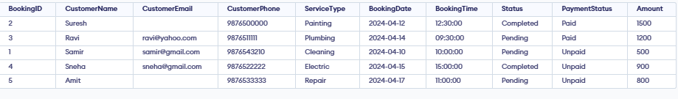
- Display all and arrange by booking date
SELECT * FROM Booking ORDER BY BookingDate;
Output
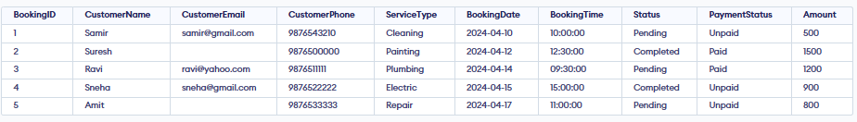
- Display booking id, customer name, booking date and time and arrange as per booking time
SELECT BookingID, CustomerName, BookingDate, BookingTime FROM Booking ORDER BY BookingTime;
Output

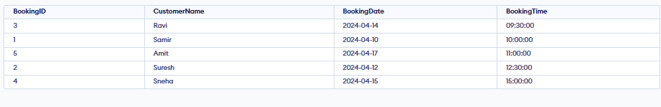
- Find out total amount according to payment status
SELECT PaymentStatus, SUM(Amount) AS TotalAmount FROM Booking GROUP BY PaymentStatus;
Output
- Find out average amount according to status
SELECT Status, AVG(Amount) AS AverageAmount FROM Booking GROUP BY Status;
Output
